ENGG1340 Computer Programming II

**Module 6 Checkpoint Exercise**

Name: Honour Oluwakorede Olatunji

University ID: 3035553484

**Instructions:**

For each single question or each group of questions in the Checkpoint exercise, please type your answer right after the question in this Word document.

**Checkpoint 6.1 (Please submit your answer to Moodle)**

There may be error(s) in the following statements. Correct the error(s) if any, if no error, please write “no error”.

1. double a [1] [2] = { {2,3}, {3,2}};

fix: a[2][2]

1. char b[1000] = "string";

no error

1. ofstream cfile;

cfile.open (c.txt, ios::ate, ios::binary); [Assuming the file c.txt exists.]

fix in line 2: “c.txt”

**Checkpoint 6.2 (Please submit your answer to Moodle)**

Consider the following code:

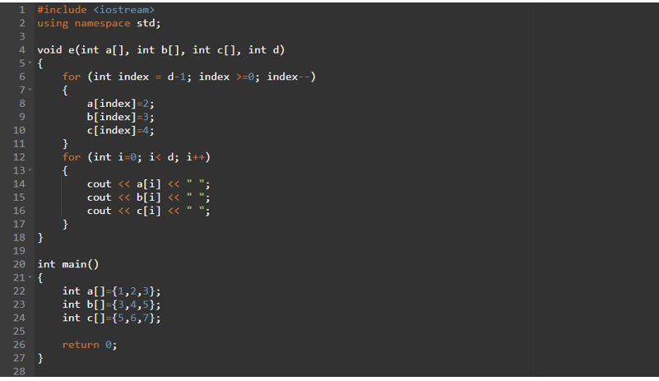

1. What is the output if the above program is executed? (if no output, please write “no output”)

Ans: no output

1. What is the output if e(a,b,c,3); is added to line 25? (if no output, please write “no output”)

Ans: 2 3 4 2 3 4 2 3 4

1. What is the output if e(a,b,c,5); is added to line 25? (if no output, please write “no output”)

Ans: 2 3 4 2 3 4 2 3 4 # # # # # #

//‘#’ represents random values.

**Checkpoint 6.3 (Please submit your answer to Moodle)**

LeetCode is a popular and famous platform and community among developers over the world. It is a well-developed platform for challenging yourselves on coding skills as well as practising and preparing for interviews for the Tech Giant companies like Google, Microsoft, Facebook, etc.

Visit<https://leetcode.com/> and register for an account by clicking “Create account” (Fig. 1). You may see the page of account sign up for registering your account (Fig. 2).



Fig. 1

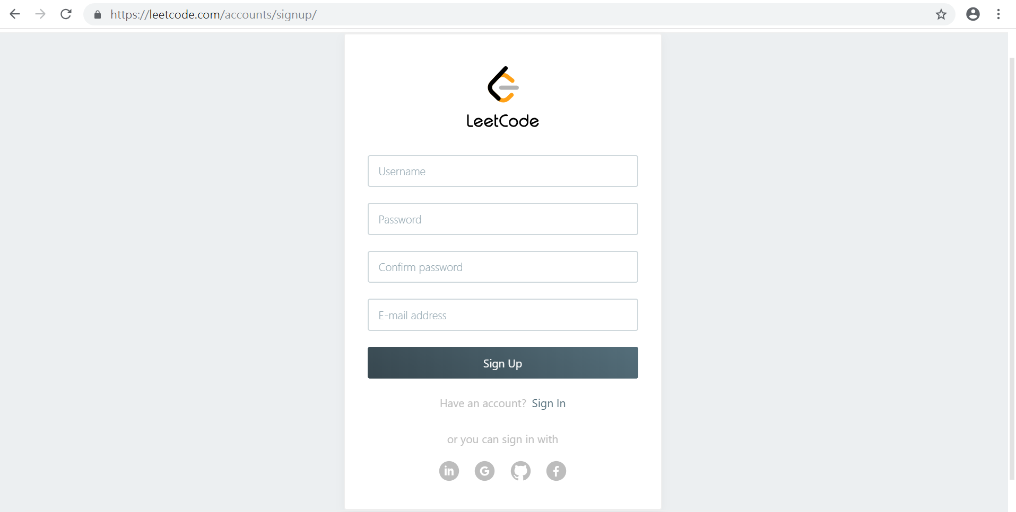

Fig. 2

After successful sign up, please login. You should be able to see the following page after login (Fig. 3). Choose Problem #1 (Title: Two Sum) and you will be brought to the problem description and a VPL-like online coding environment (Fig. 4).

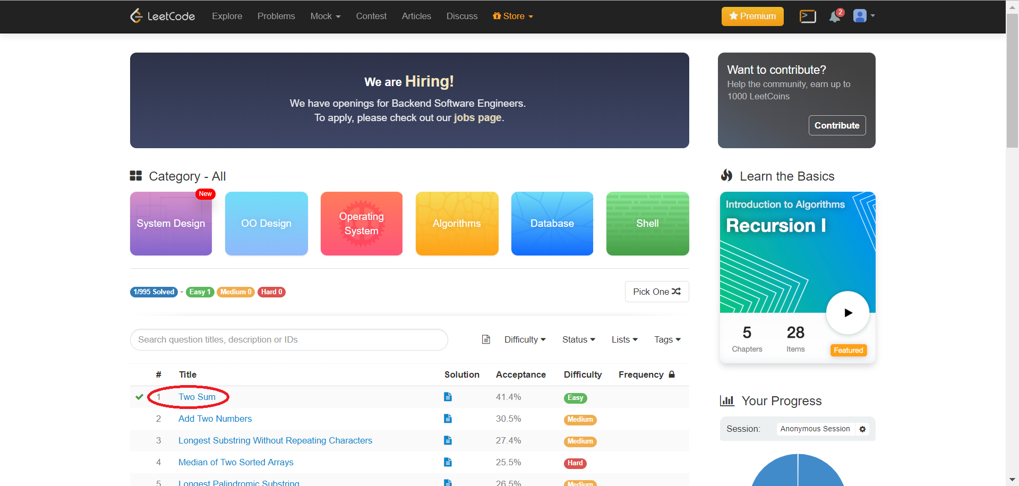

Fig. 3

Note that you may choose different programming languages to tackle the problem. Let’s use C++ for your submission (Fig. 4).

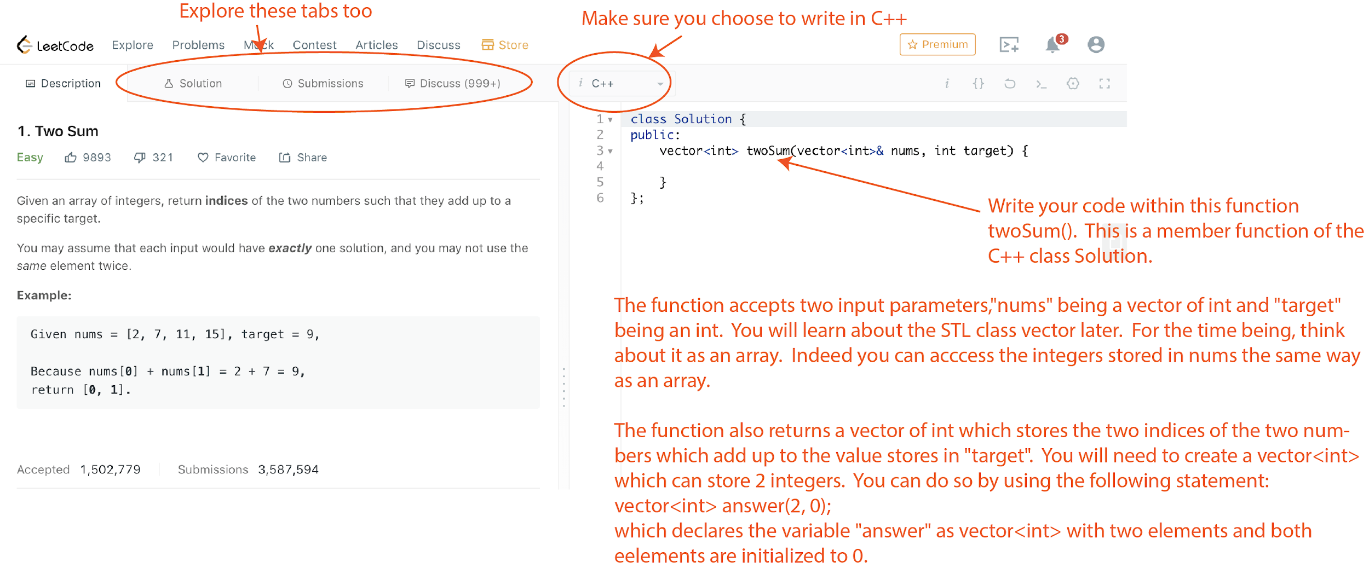

Fig. 4

Explore also the tabs “Solution”, “Submissions” and “Discuss”. In particular, under “Submission”, you will be able to find the information of your submissions (Fig. 5).

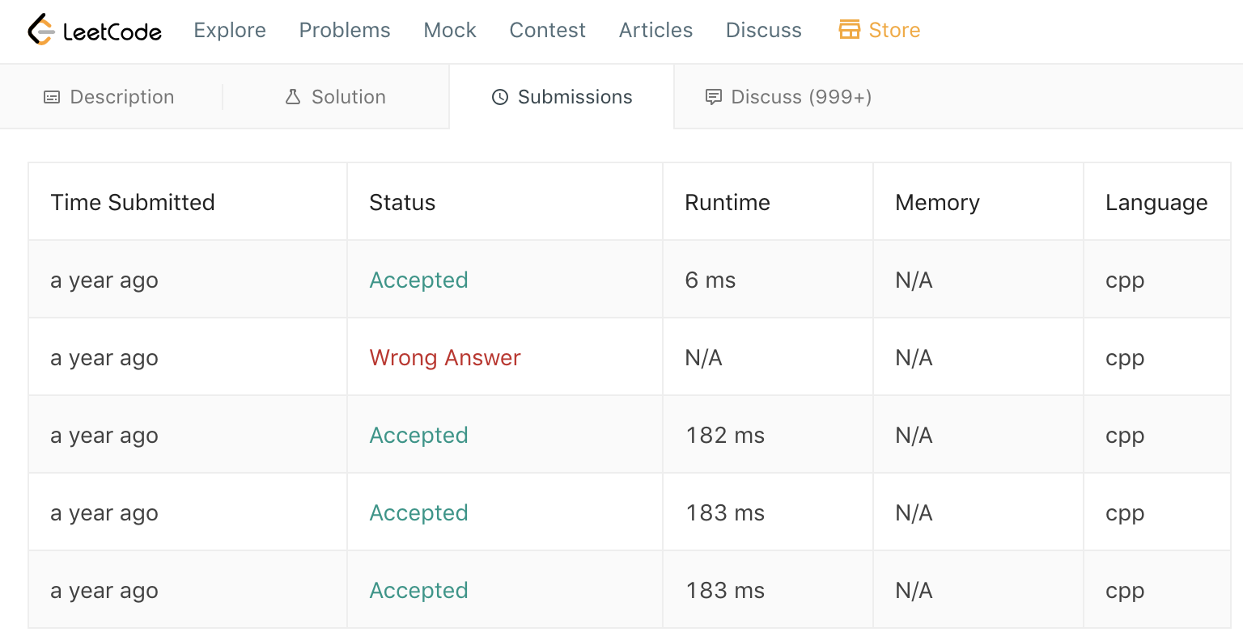

Fig.5

When you click on the status of each submission, you will be able to see the runtime (i.e., how fast your solution is) and the memory consumption. Also, you can see how your solution is ranked among other submission from all over the world in terms of runtime (Fig. 6). You can keep improving your solution in order to beat the others!

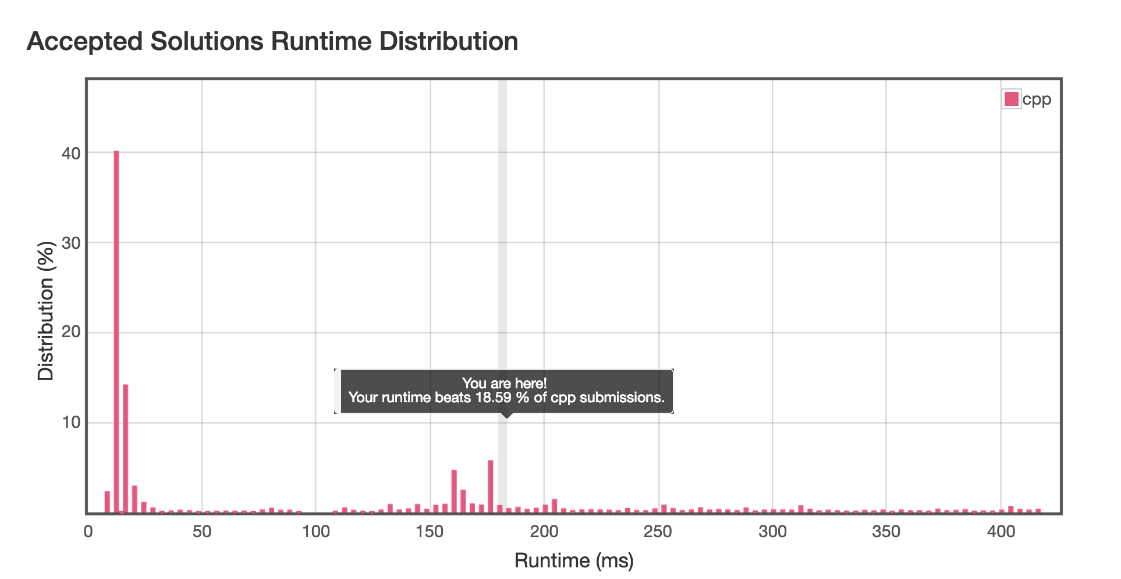

Fig. 6

**Please complete Problem #1 (Title: Two Sum) and provide a screen capture (similar to that in Fig. 5) for your submission.**

An example (vectorcode.cpp) for a simple usage of vector is included for your reference.

My ScreenShot

